

**Invoicing Process**

*All costs for a project should be provided in a job confirmation at a start of a project and signed off by client (so there are no queries with an invoice)*

*Unless we have a specific agreement with client all invoices are to be created within 48 hours of project completion and all PO’s as should be sent to us by project completion.*

***Important*** *- Once an invoice has an invoice number, NEVER make any further changes to it – it has been posted to our accounts system Sage. If you have made an error and need to change the amount charged speak to Claire R or your line manager about how we should go about rectifying it.*

**Stage 1**

* **Create a new invoice for your client in the client folder.**
  + Path:\\192.168.1.4\alchemy\production\campaign_manager\invoicing\client_invoices
  + There should be a folder for each client
  + Each client should have an invoice spreadsheet per month of each year
    - Eg Aviva_invoices_2012_March
    - Aviva_invoice_2012_April
    - Aviva_invoice_2012_May
* **Ensure all the below details are inputted and are correct on the invoice**
  + Company contact (person the invoice is to be sent to) and the full company address. (Please ensure Georgia has these details too along with the email address so she can email the invoice to the client contact)
  + Enter the full date the invoice is being raised in the ‘date’ field. This should be the same date you enter the invoice under on the master calendar sheet.
  + If we have PO – enter this in the correct field or state N/A if no PO is required
  + List out **all** the service items of the invoice and the amount charged (unless otherwise agreed with client. If service items are not listed please email Georgia the breakdown of what is covered (html/design/deployment etc so she can apply nominal codes to the separate invoice values)
  + Check the CM fee – if it’s a % check this is correct
  + Check the invoice total – is this correct?
  + Check VAT of 20% for UK clients is added
  + The tab at the bottom of the invoice should be updated to todays date for example ‘20122012’
  + Ensure our bank details are on the template ( they are different for US and UK)
    - For an example of a completed invoice see here cpw_example_invoice.pdf

**Stage 2**

* **When a invoice is completed, update the master invoice document**
  + Path: [..\..\invoicing\2013](../../invoicing/2013) There is a separate spreadsheet for each month
  + Please enter the project number to the date you have created the invoice. Adding it to the bottom of the list of projects already added for that ( It is important that if you are creating the invoice on the 22nd of the month, that you DO NOT add the invoice to the 20th or before any invoices that have already been given a number by Georgia . The invoice should be added below the last invoice with an invoice number)
  + The example below. If were raising an invoice on the 3rd April you would add it on the row below “SB: sb_p5297_redeye_mcs194” on the 3rd April

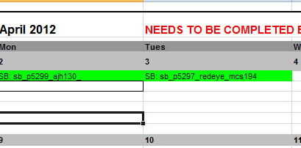

**Colours confirmation.**

* **Blue: Enter the project number in blue if the invoice is completed and is ready to be inputted onto Sage and be given an invoice number – but is still requires a PO**
  + **Only enter it in blue if all details on invoice are correct**
* **Green shading -** If you have a PO listed on invoice (or if no PO is required) please shade the project number in green and amend the font to black.
  + At this stage you should be actively chasing for the PO number if we require one. As the invoice cannot be sent until we have a PO on the invoice
  + Other colour codes: Red - Not for CM but for Georgia – this shows that the invoice has been processed. **At this stage, DO NOT AMEND the invoice** if the invoice is in red on the master invoice sheet or the invoice has an invoice number. This is very important ( if you need to amend once this has occurred please speak to Georgia/Claire for next steps) as it means we have posted the invoice amount onto Sage.
  + If at any stage you receive a PO for an invoice you have created (once it is red and been inputted onto Sage) please always inform Georgia that you have added PO to the invoice and change it to green in the calendar/master invoice sheet.
  + Georgia will then send invoice to client

**Stage 3**

* Please also complete the ‘client total’ sheet on the 2nd tab of the master invoicing sheet .

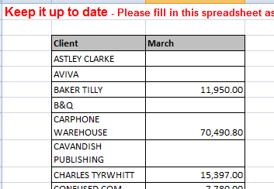

* Each time you create a new invoice add the amount to the client total, so there is a running total of how much we have invoiced for each client

**Stage 4**

* Keep chasing client by phone until we receive a PO for invoice. The invoice and therefore the project is not complete until this has been added to the invoice
* When you receive the PO ALWAYS email Georgia to let her know the PO has been received and that she can send the invoice out
* When you receive the ‘missing PO List’ from Georgia you should be going through this and checking all invoices for your clients. If they have a PO and are on the list in error, please notify Georgia immediately. All others should be chased.